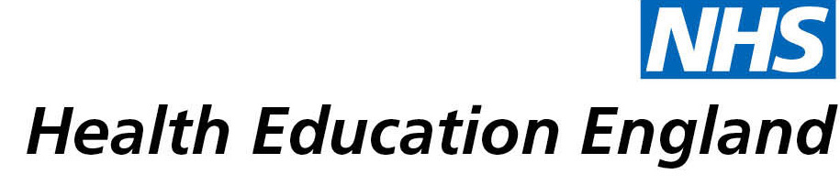

# Knowledge and Library Services Case Study

# *Coventry and Warwickshire Partnership Trust: Procedure update for Lung Volume Recruitment Bag*

Date *25/1/2022 – original enquiry august 2021 with updates in oct/nov*

## Reason for enquiry

*Literature search to inform updating of a Trust wide clinical procedure for a specific technique/piece of equipment.*

*Literature search for Up to date evidence to inform practice and ensure no practice changes in relation to pandemic*

*Literature search to ensure no new information since last review 3 years ago*

*Literature search to allow bench marking*

## What the knowledge and library specialist did

*Conducted literature searches update about The Lung Volume Recruitment Bag using a variety of search terms.*

# Impact of input from the library and knowledge service

*Supported a clinical procedure update, by ensuring applying most up to date evidence on the specific technique,*

*Also allowed for understanding of pending research being planned into the technique to gain an idea of possible future practice changes.*

*All of the above ensure patients are receiving evidence based and up to date care.*

*Also ensured using best available evidence/clinical recommendations where larger scales are not yet available.*

*Some of this information has been shared with the local acute trust who are also developing their own procedures.*

*A small number of pertinent pieces of literature are also used in teaching to peers and other professionals to aid understanding of the technique*

*Having the right information quickly accessible without requiring extensive time taken away from clinical practice to perform searches is incredibly beneficial. It also ensures information isn’t missed. Without this service, updates would not be as through or as rigorously reviewed due to time and skill constraints with the level of searching and time required*

## Immediate Impact

*Timely update of clinical procedure as new information quickly accessible*

*Triggered local clinicians meeting to review technique and update practice incorporating new information. Also enhancing local community and acute hospital links.*

## Probable future Impact

*Up to date procedure*

*Awareness of new studies being planned for potential practice changes in the future.*

## Name and Job Title:

*Helen Day Specialist Palliative Care Physiotherapist*

*(SPCT – specialist pallative care team, CHWB- community health and wellbeing directorate, CWPT)*

## For further information on how you can get similar support contact your local NHS library and knowledge service.

**Submission Details**

***[To be completed by Knowledge and Library Service at the point of submission]***

**Name of Organisation**

*Coventry and Warwickshire Partnership Trust*

**Knowledge and Library Service Contact Email:**

*Claire.bradley@covwarkpt.nhs.uk*

**Title of Case Study**

*Procedure update for Lung Volume Recruitment Bag*

**NHS Region** *[Make bold the option which applies:]*

East of England

London

**Midlands**

North East and Yorkshire

North West

South East

South West

**Sector** *[Make bold the option which applies:]*

Acute

Acute and community

Care Trust

Clinical Commissioning Group

Commissioning Support

Community Trust

Cross-sector

Local Education and Training Board

**Mental Health**

Mental Health / Learning Disability

Mental Health / Social Care

Primary Care

Public Health

Shared Service / Informatics

Special HA

Other. If other, please specify

**Group Impacted** *[Make bold the option which applies:]*

Additional Clinical Services

Administrative and Clerical

**Allied Health Professionals**

Estates and Ancillary

**Healthcare Scientists**

Medicine and Dental

Multiprofessional

Patients, Carers and the Public

Nursing and Midwifery

Scientific and Technical

Students

**Impact Types** *[Make bold any of the impact types below which apply]*

Contributed to personal or professional development

Contributed to service development or delivery

Facilitated collaborative working

Health Information for Patients, Carers and the Public

Improved the quality of patient care

Mobilising evidence and organisational knowledge

More informed decision making

Productivity and efficiency

Reduced risk or improved safety

Saved money or contributed to financial effectiveness

Improved health and wellbeing of staff and learners

**Consent**

I have consent from individuals referred to in this case study to share details nationally for advocacy and promotion. *[Make bold the option which applies:]*

**Yes**

No